**Monsoon 2025**

# **First Flood Peak:**

On 26th August 2025, heavy to very heavy rainfall occurred in the catchment areas of the Chenab, Ravi, and Sutlej rivers. Sialkot alone recorded more than 360 mm of rain in 24 hours, breaking a 49-year historical record. As a result, significant flood peaks were generated due to intense rainfall across northeastern Pakistan including Lahore, Narowal, Sialkot, Gujrat, Kasur, Gujranwala and in the transboundary catchment areas of the eastern rivers.

In the Chenab River, a flood peak of 902,240 cusecs was recorded on 27th August at 0200 hrs. This was further intensified by contributions from local nullahs such as Aik, Phalku, Jammu Tawi, and Munawar Tawi originating from the Pir Panjal Range resulting in peak discharges of 1,085,750 cusecs at Khanki and 1,077,951 cusecs at Qadirabad (the highest since 1992), recorded at 1000 hrs and 1800 hrs on 27th August, respectively.

To reduce flood pressure, a controlled breaching section was activated at *Qadirabad (RD 8000 of the Right Marginal Bund)* with the assistance of the Pakistan Army's 30 Corps. The peak later reached Chiniot Bridge with a maximum discharge of 855,000 cusecs on 28th August. It then attenuated further at Trimmu Barrage, where the discharge dropped to 550,965 cusecs by 1st September due to both the earlier activation of a breaching section downstream of Chiniot Bridge near *Rivaz Bridge* and the long lag time and travel distance.

Currently, the first flood peak of the Chenab is passing through Multan and Muzaffargarh areas with estimated flows between 450,000 and 500,000 cusecs. At the confluence point of the Chenab and Ravi rivers in districts Jhang and Khanewal, an additional 110,000–120,000 cusecs are being added to the Chenab’s flow, also causing backwater effects at the junction. The combined flows from the Chenab, Ravi, and Sutlej rivers are expected to reach 550,000 to 600,000 cusecs at Panjnad Barrage by tonight or tomorrow afternoon.

On 7th–8th September, approximately 220,000 cusecs from the Indus River are expected to merge with the 550,000–600,000 cusecs from the Chenab system at Guddu Barrage bringing the total expected discharge to around 700,000 cusecs. This flood volume is forecast to take 32–36 hours to travel from Guddu to Sukkur, likely reaching there with around 600,000 cusecs on 8th–9th September.

On the Ravi River, a flood peak of 240,500 cusecs was recorded at Jassar on 27th August, caused by local nullah flows, heavy rainfall, and spillway releases from Thein Dam. This peak reached Shahdara Bridge with 219,770 cusecs on 28th August and then Balloki Headworks with 223,385 cusecs on 30th August after a 38-hour journey. From Balloki, the flood took another 71 hours to reach Sidhnai Headworks, where it peaked at 193,470 cusecs on 3rd September. As this exceeded Sidhnai design capacity of 175,000 cusecs, a breaching section was activated upstream at the Mai Safuran embankment to relieve pressure and ensure the structural safety of the headworks.

In the Sutlej River, extremely high flows have persisted at Ganda Singh Wala for the past 10 days, with a peak discharge of 385,569 cusecs recorded on 29th August. As of today, the flow remains high at 311,673 cusecs. At Suleimanki Headworks, the maximum recorded discharge was 154,219 cusecs on 31st August, with current flows around 140,000 cusecs. Islam Headworks is currently experiencing medium flows at 102,045 cusecs. The estimated flows from the Sutlej River to the overall system is around 100,000 cusecs.

|  |
| --- |
|  |

|  |
| --- |
|  |

**Second Flood Peak:**A very high flood surge was recorded in the Chenab River at Marala Headworks on 3rd September 2025 at 1200 Hrs. due to low pressure system over catchment areas of Ravi, Chenab and Sutlej, with a peak discharge of 548,237 cusecs. The flood wave is expected to reach Khanki Headworks by 2000 hrs the same day, with a slightly increased discharge of 558,237 cusecs. It will continue downstream to Qadirabad Headworks by 0300 hrs on 4th September, maintaining a high flow of 550,237 cusecs. The flood is forecast to attenuate as it progresses, reaching Trimmu Headworks by 8th September at 0700 hrs with a reduced flow of 330,226 cusecs, and subsequently arriving at Panjnad Headworks by 11th September at 2000 hrs with 264,980 cusecs. The floodwaters are then expected to reach Guddu Barrage on the Indus River by 13th September at 2000 hrs, carrying 217,283 cusecs from the Chenab, in addition to approximately 250,000 cusecs from the existing Indus flows resulting in a combined discharge that poses significant flood risk to downstream areas.

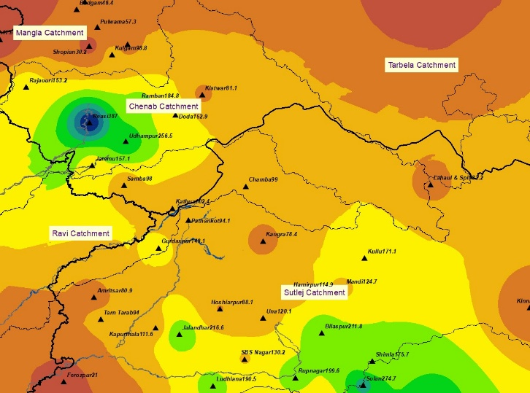 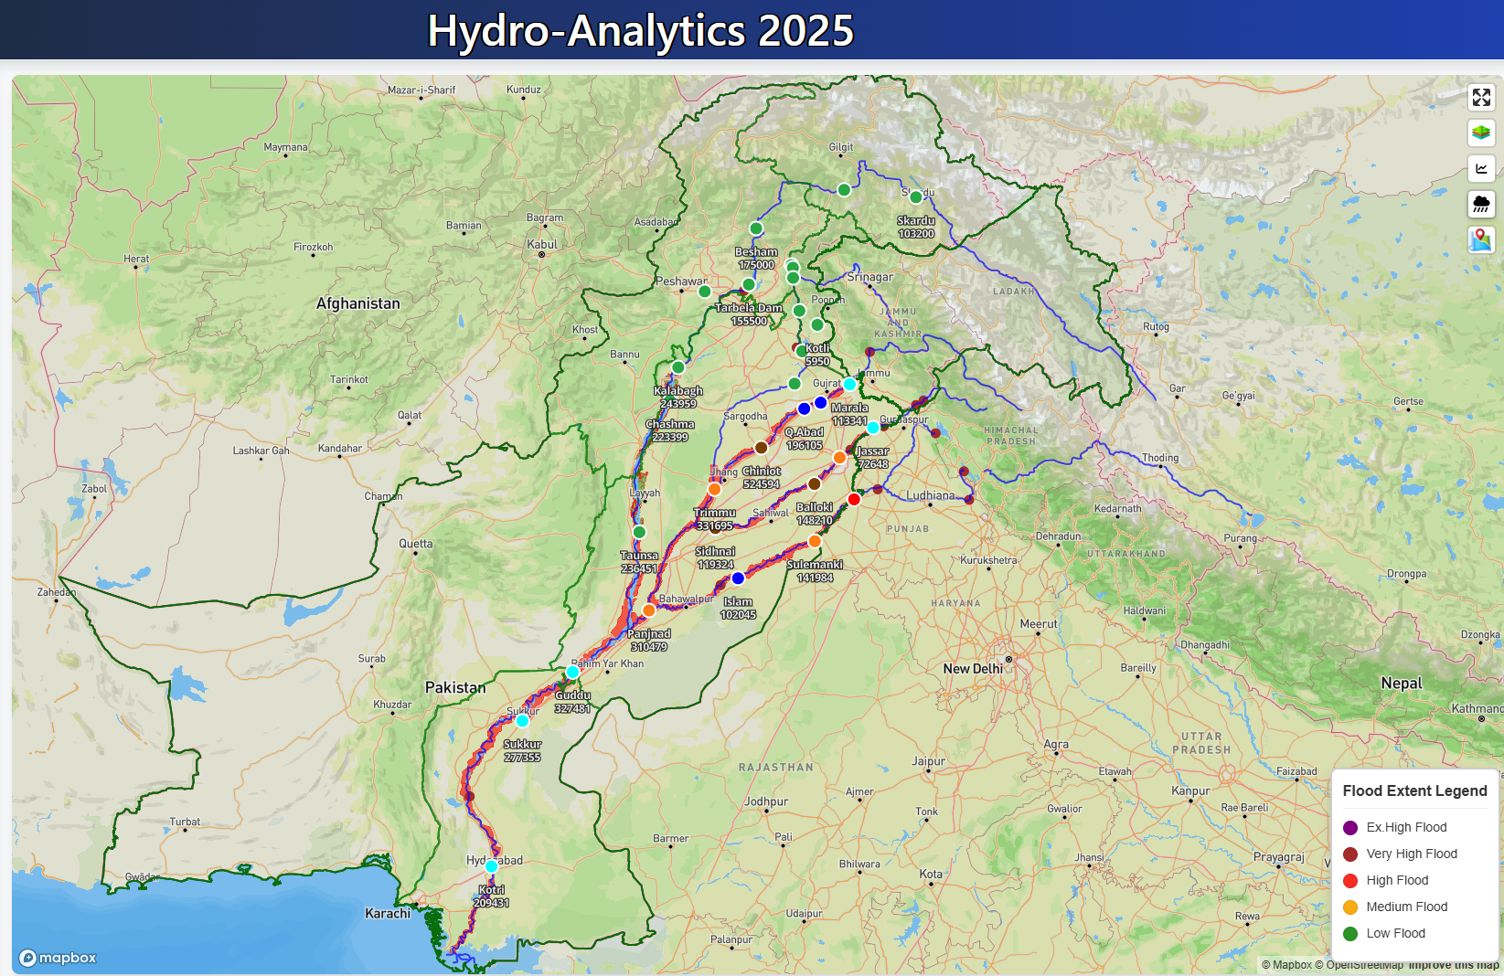

Another Low-Pressure System is active over Indian Rajasthan & Gujrat that will cause rainfall over South eastern parts of Sindh. A low-pressure system is currently located over Madhya Pradesh (India) and likely to move westwards and may reach Rajasthan during next 24 hours. Monsoon currents are penetrating in Sindh and eastern parts of Punjab, which may likely to intensify from tomorrow (evening/night).

